***EXPERIMENT NO.6 2D TRANSFORMATION***

Program for translation:-

#include<stdio.h>

#include<conio.h>

#include<graphics.h>

#include<math.h>

void main()

{

int gd=DETECT,gm;

int x1,y1,x2,y2,tx,ty,x3,y3,x4,y4;

initgraph(&gd,&gm,"C:\\TurboC3\\BGI");

printf("Enter the starting point of line segment:");

scanf("%d %d",&x1,&y1);

printf("Enter the ending point of line segment:");

scanf("%d %d",&x2,&y2);

printf("Enter translation distances tx,ty:\n");

scanf("%d%d",&tx,&ty);

setcolor(5);

line(x1,y1,x2,y2);

outtextxy(x2+2,y2+2,"Original line");

x3=x1+tx;

y3=y1+ty;

x4=x2+tx;

y4=y2+ty;

setcolor(7);

line(x3,y3,x4,y4);

outtextxy(x4+2,y4+2,"Line after translation");

getch();

}

Output:-

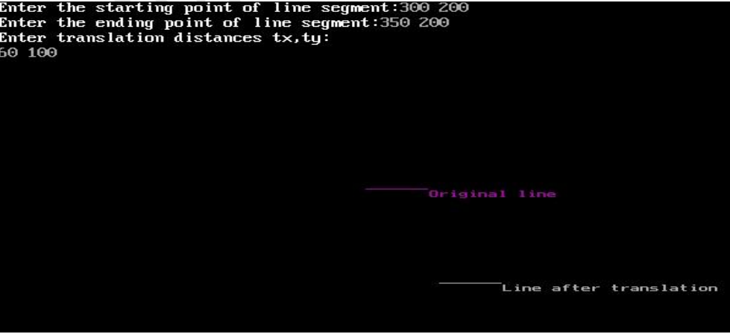

Program for scaling:-

#include<stdio.h>

#include<conio.h>

#include<graphics.h>

#include<math.h>

void main()

{

int gd=DETECT,gm;

float x1,y1,x2,y2,sx,sy,x3,y3,x4,y4;

initgraph(&gd,&gm,"C:\\TurboC3\\BGI");

printf("Enter the starting point coordinates:");

scanf("%f %f",&x1,&y1);

printf("Enter the ending point coordinates:");

scanf("%f %f",&x2,&y2);

printf("Enter scaling factors sx,sy:\n");

scanf("%f%f",&sx,&sy);

setcolor(5);

line(x1,y1,x2,y2);

outtextxy(x2+2,y2+2,"Original line");

x3=x1*sx;

y3=y1*sy;

x4=x2*sx;

y4=y2*sy;

setcolor(7);

line(x3,y3,x4,y4);

outtextxy(x3+2,y3+2,"Line after scaling");

getch();

}

Output:-

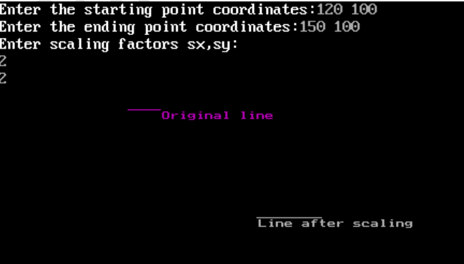

Program for rotation:-

#include<stdio.h>

#include<conio.h>

#include<graphics.h>

#include<math.h>

void main()

{

int gd=DETECT,gm;

float x1,y1,x2,y2,x3,y3,x4,y4,a,t;

initgraph(&gd,&gm,"C:\\TurboC3\\BGI");

printf("Enter coordinates of starting point:\n");

scanf("%f%f",&x1,&y1);

printf("Enter coordinates of ending point\n");

scanf("%f%f",&x2,&y2);

printf("Enter angle for rotation\n");

scanf("%f",&a);

setcolor(5);

line(x1,y1,x2,y2);

outtextxy(x2+2,y2+2,"Original line");

t=a*(3.14/180);

x3=(x1*cos(t))-(y1*sin(t));

y3=(x1*sin(t))+(y1*cos(t));

x4=(x2*cos(t))-(y2*sin(t));

y4=(x2*sin(t))+(y2*cos(t));

setcolor(7);

line(x3,y3,x4,y4);

outtextxy(x3+2,y3+2,"Line after rotation");

getch();

} Output:-

